**Assignment Information and Goal**  
In this class assignment you will demonstrate a detailed knowledge of Drupal 8 CMS site development skills by creating a Drupal 8 site and extending it with media, JavaScript Libraries, modules, and custom content types.   
  
**Assignment questions are not as detailed as activity questions. The assignment is where you demonstrate understanding of the material.  
  
Read All Project Documents before Starting the Work**Please read this document completely before starting the project work.   
Please also read the template so that you understand what information, content, and screens you are required to capture and insert into the template file.

**Documents for This Assignment:**   
This is the assignment instructions document.   
It contains the information on the necessary tasks to be completed for the assignment.  
The other documents associated with this assignment are the assignment template, the website content, and the rubric.   
  
**Website Content document:**   
The Website Content document contains business information and all the necessary CMS web page content required to create the Drupal site.   
  
**Template File:**   
Please download, rename, complete and then submit the assignment template document to receive a grade for this assignment. Please provide partial screen captures where requested.  
The rubric provides detailed information on how the assignment is graded.  
**PLEASE DO NOT DELETE PARTS OR ALTER SECTION FORMATTING OF THIS TEMPLATE**

**Assignment Asset Folders and Website Content**   
There are asset folders that contain images and website page and post content.  
The asset folders contain images and content to use on the CMS website.   
Please use the content and image assets provided on the D2L CMS to complete the assignment.  
When instructed, use IPSUM content for Page content.

**Creating the Drupal 8 Website:**Create a new Drupal 8 CMS website.  
Create the Drupal 8 site as an “In Directory” website on a shared web host or Pantheon.  
Please use all lower case in directory name when creating the website.   
Drupal can create case sensitive website URLs so please adhere to the instructions for site name.   
Please contact the instructors if you have questions about the assignment, content layout, or formatting.

Part A - Student Information

1. Download and save a copy of the Assignment 10 Template document
2. Rename the template document **[Your-Initials]-**Assignment10.docx
3. Go to the template and enter Part A student information.

Part B - Create Drupal 8 CMS Website - Shared web Host or Pantheon

1. If you are using a shared web host create an “In Directory” Drupal 8 CMS website with the following attributes **For Shared Web Host:**

**Protocol:** http:// **Domain:** Select your default domain **In Directory:** “assignment10”

**Site Name:** “Assignment 10 Drupal 8 Site”

**Site Description:** “IT320 Assignment 10”  
-OR-  
**For Pantheon:**

If you are creating a Pantheon Drupal 8 site, create a site with the following attributes:  
**Site Name:** “Assignment 10 - PA”

1. Go to the template and record website creation settings in part B.

**Part C - Review the Assets Media Record Structure and Content text File**

The following is a screen capture of the Assets file   
“Media Record Structure and Content.txt “   
  
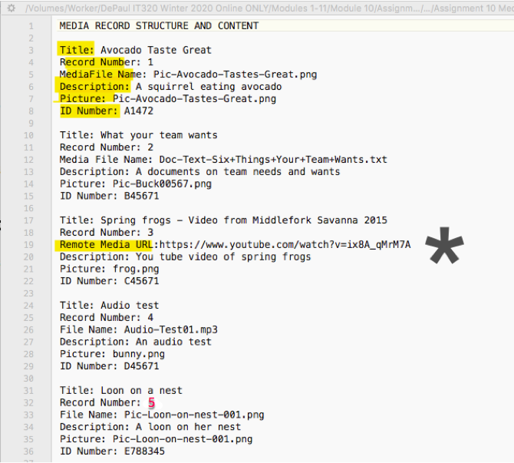

The “Media Record Structure and Content.txt” file contains the record structure, field names and values for 5 (five) Media records.

Each Media record contains information about the fields and values used to create a new custom Content Type named “Media record”.

Each record has a media type of Audio, Picture, Document, or Remote Video.

Install the Admin toolbar and Module filter modules to enhance the ADMIN TOOL BAR AND THE EXTEND ADMIN PAGE.  
  
Enable the CORE Media and Media library modules.

Add all media files listed in the “Media Record Structure and Content.txt” file to your Drupal 8 site.  
  
Go to the template and take the screen captures **Part C**, and in the template.

**Part D - Create Custom Content Type named “Media record”**

1. Create a new custom content type named “Media record”
2. Please add help text for all fields
3. Add all fields based on the to the template structure
4. Set Publishing options to “Published” only – do not promote to the front page
5. Menu settings – Uncheck all menu settings.
6. Configure Manage display labels as you see fit

Go to the template; answer the questions for **Part D**, and in the template.

**Part E – Add “Media record” nodes to the system**

1. Add all five data records (nodes) to the system adding all field items to each record.

Go to the template; answer the questions for **Part E**, and in the template.

**Part F – Create a “Media record view” Page View of Full Posts**Navigate to the View settings page and   
(1) Enable the “always show Advanced display settings” option  
(2) In the LIVE PREVIEW SETTINGS section, enable the “Show SQL query” option   
(3) Press the “Save configuration” button

View is created with the following attributes:

1. View name “My media record view”
2. Description: “A teaser view of type Media record.”
3. View settings:
   1. Show: Content
   2. Of type: Media record
   3. sorted by: Title
4. Select (check) Create a page
5. Page title and path: default values
6. PAGE DISPLAY SETTINGS
   1. Display format: Unformatted list
   2. Of: Full Posts
7. Items to display: 3
   1. Use a pager: checked
   2. Create a menu link: checked
      1. Menu: main navigation
      2. Link text: keep default value

Go to the template, take screen captures for **Part F**, and in the template.

**Part G – Add a new Media Type:**

1. Review the Module 10 presentation “M10 -04- Creating Drupal 8 Custom Media Types”
2. Follow along with the presentation
3. Create a basic page named named “**Instagram post test**”
4. Embed an instagram post on a Basic Page– within the Body
   * You can use the Instagram link listed in the Assets file   
     “Social-Instagram Links.txt”: <https://www.instagram.com/tv/B763i6Xg9IBRoivv9uvxTWUfTOTxL-pqYAknTU0/>
   * Or use your own instragram video link

Go to the template, and answer the questions about Drupal 8 API Hooks for **Part G**, and in the template.

**Part H – Add JavaScript Libraries and Modules**

Add the Text Color and Background Color buttons to the Full HTML text editor Toolbar.  
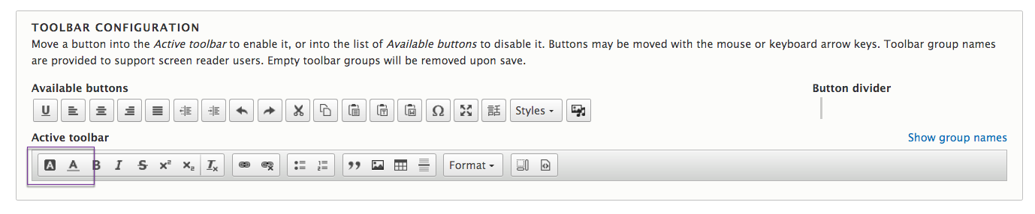

1. **Install the Following JavaScript Libraries on your Drupal 8 site:**

FlexSlider JavaScript Library: (do not forget to rename it to flexslider)  
<https://github.com/woocommerce/FlexSlider>

Panel Button JavaScript Library:  
<https://ckeditor.com/cke4/addon/panelbutton>

Color Button JavaScript Library:<https://ckeditor.com/cke4/addon/colorbutton>

1. Install and enable the following Drupal 8 Modules on your Drupal 8 site:  
     
   **Drupal 8 Flex Slider & Libraries API Modules:**[**https://www.drupal.org/project/flexslider**](https://www.drupal.org/project/flexslider)

[**https://www.drupal.org/project/libraries**](https://www.drupal.org/project/libraries)

CKEditor Color Button Drupal 8 Module:  
<https://www.drupal.org/project/colorbutton>

Panel Button Drupal 8 Module:  
<https://www.drupal.org/project/panelbutton>

1. **Enable the CKEditor Color Button module**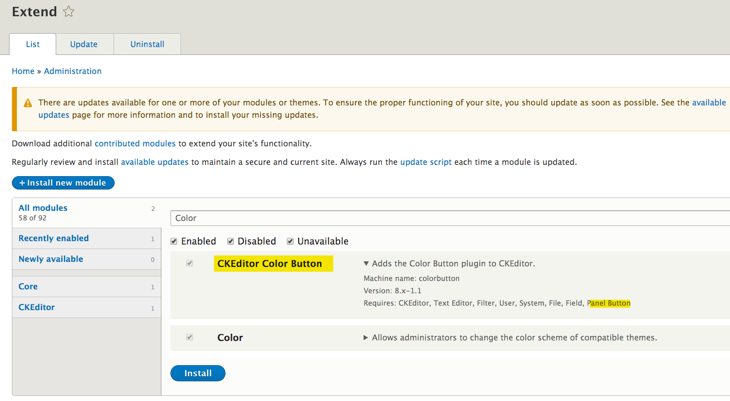
2. **Add the Text Color and Background Color buttons to the Full HTML text editor Toolbar**

**Admin toolbar > Configuration > CONTENT AUTHORING > Text formats and Editors**



1. Crate a new Basic page named “Color test”
2. Add 3 paragraphs of IPSUM body content – Suggested site Hipster IPSUM

<https://hipsum.co/>

1. Switch the Body Text format to “Full HTML”  
   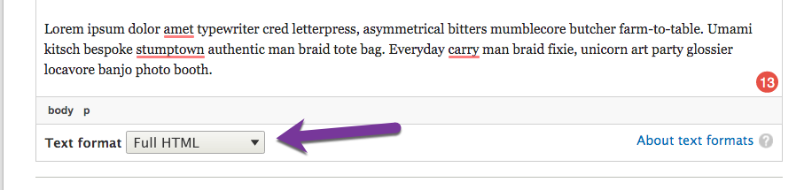
2. Use the Background color button to make the first paragraph background color BLUE
3. Make the second paragraph TEXT color PURPLE
4. Make the Third paragraph TEXT color GREEN  
   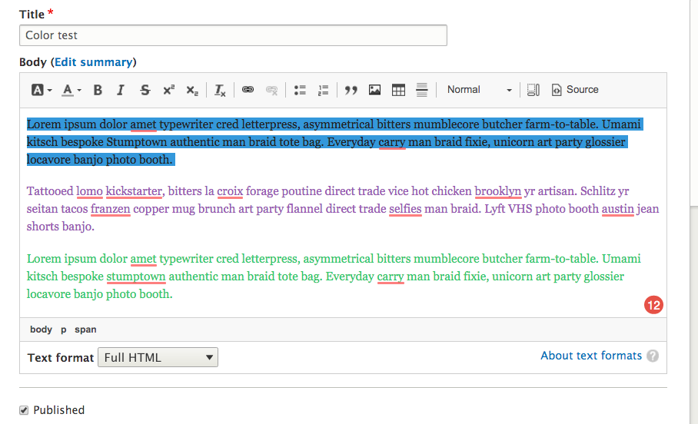
5. **Add a main navigation menu link**
6. **Save your work**
7. **View the page on a different web browser as an anonymous user.**

Go to the template; take the requested screen captures for **Part H**, and in the template.

**Part I – Assignment Wrap up:**

1. Go to the template and answer the questions in Part I, the assignment wrap up.
2. After that submit your renamed template to D2L.